**FedEx Dataworks Data Engineer Interview Guide – Experienced 3+**

**Technical round 1 and 2 combined**

**1. How to Copy All 1000 Tables from Source to Target in ADF**

Use Metadata Activity: Use the Metadata activity to fetch the table details (table names and columns) from the source.

Use ForEach Activity: After gathering the list of tables, use the ForEach activity to iterate through each table name.

Use Copy Activity: Within the ForEach activity, use the Copy Activity to copy the data from the source to the target.

Example:

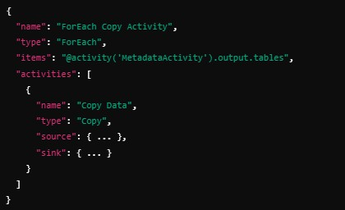

**2. Trigger Types in ADF – Discuss Scheduled, Tumbling Window, and Event-Based**

**Triggers**

• **Scheduled Trigger**:

Definition: Triggers the pipeline on a set schedule (e.g., daily, hourly). Use Case: Use when you want a pipeline to run at regular intervals.

• **Tumbling Window Trigger**:

Definition: Creates a window of fixed duration (e.g., every hour, day). Each trigger is independent.

Use Case: Use when you need to perform time-based operations on a continuous schedule.

• **Event-Based Trigger**:

Definition: Triggers a pipeline based on an event (e.g., file upload in Blob Storage).

Use Case: Use when you want to trigger a pipeline after a specific event occurs, like a new file landing in a storage location.

**3. Linked Service and Dataset – Explain Their Roles in ADF**

• **Linked Service**:

**Definition**: A Linked Service defines the connection information for a specific data store (e.g., Azure SQL Database, Blob Storage). It allows ADF to connect to source or destination.

**Dataset**:

**Definition**: A Dataset represents the data structure (e.g., a table, file, or folder) that is being used in the pipeline. It is often associated with a linked service to point to the data source.

**4. Data Warehouse vs Data Lake vs Data Lakehouse – Compare Features and Use** **Cases**

**Data Warehouse**:

Definition: A structured repository designed to support reporting and analytics. It typically uses schemas like star or snowflake.

Use Case: Best for structured data with historical reporting needs.

**Data Lake**:

Definition: A large, unstructured data repository that can store raw data in any format (e.g., text, images, logs).

Use Case: Ideal for big data, machine learning, and raw, unstructured data storage.

**Data Lakehouse**:

Definition: Combines the features of both data lakes and data warehouses. It supports structured, semi-structured, and unstructured data, with features like ACID transactions.

Use Case: Ideal for organizations that need both analytical queries and unstructured data storage.

**5. How to Run One Notebook in Another Notebook – Example in Databricks**

In Databricks, you can run one notebook from another using the dbutils.notebook.run()

method:

result = dbutils.notebook.run("/path/to/other_notebook", 60)

• 60 is the timeout in seconds.

• This will execute the notebook and return the result.

**6. Workflow in Databricks – Steps to Create and Schedule a Job**

• **Steps to Create a Job**:

1. Navigate to the Jobs section in Databricks.

2. Click on Create Job and provide a name for the job.

3. Add a task that points to the notebook or JAR you want to execute.

4. Set the cluster configuration (e.g., job cluster or shared cluster).

• **Steps to Schedule**:

1. Under the job settings, configure the Schedule.

2. Set the frequency (e.g., daily, weekly).

3. Specify time and recurrence.

**7. How Many Jobs/Stages/Tasks Are Created – Explain Spark’s Execution Plan**

• **Jobs**: Each action (like collect(), save(), count()) creates a job.

• **Stages**: Spark divides jobs into stages based on transformations that require shuffling.

• **Tasks**: A stage is divided into tasks, each corresponding to a partition of the data. To see the execution plan in Databricks, you can use:

df.explain(True)

**8. Repartition vs Coalesce – Differences and Scenarios for Use**

• **Repartition**:

Definition: Increases or decreases the number of partitions by reshuffling the data.

Use Case: Use when increasing partitions to optimize parallel processing (e.g., repartition(10)).

• **Coalesce**:

Definition: Reduces the number of partitions without full shuffle.

Use Case: Use when reducing partitions (e.g., before saving output) to avoid small file problems (e.g., coalesce(1)).

**9. Broadcast Join – When and How to Use It**

**When to Use**: Broadcast joins are used when one dataset is significantly smaller than the other. Broadcasting the smaller dataset avoids shuffling the larger dataset.

**How to Use**:

from pyspark.sql.functions import broadcast df_large.join(broadcast(df_small), "key")

**10. Create Spark Session, Read CSV, Join, and Write as Table – Provide Example Code**

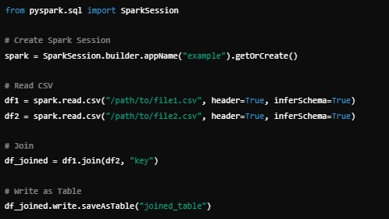

**11. SQL Query to Find Top 3 Earners in Each Department**

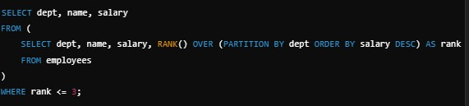

**12. Rank vs Dense Rank – Differences and Use Cases**

• **Rank**:

Definition: RANK() assigns a rank to each row, skipping ranks in case of ties. Use Case: Use when you want gaps in ranking for tied rows.

**Dense Rank**:

Definition: DENSE_RANK() assigns a rank without skipping any values in case of ties.

Use Case: Use when you want continuous ranking, even for ties.

**13. Print Even Numbers from a List – Python Example**

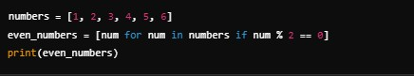

**14. Wide vs Narrow Transformations – Explain with Examples**

• **Wide Transformations**:

Definition: These transformations involve shuffling data (e.g., groupByKey(), reduceByKey()).

Example: groupByKey() performs a wide transformation as it requires data shuffling.

• **Narrow Transformations**:

Definition: These transformations don’t involve shuffling (e.g., map(), filter()). Example: map() applies a function to each element in the dataset.

**15. Adaptive Query Execution (AQE) in Databricks – Explain its Benefits**

**Definition**: AQE in Databricks optimizes query execution plans dynamically at runtime based on the data distribution and runtime statistics.

• **Benefits**:

Dynamic Partition Pruning: Avoid scanning unnecessary partitions.

Join Optimization: Dynamically adjust join strategies based on runtime data. Cost-based Optimizations: AQE adapts the plan to minimize the cost of query execution.

**16. Interactive Cluster vs Job Cluster – Differences and Use Cases**

• **Interactive Cluster**:

Definition: A cluster that is used for interactive analysis and notebook execution.

Use Case: Ideal for development, testing, and debugging.

• **Job Cluster**:

Definition: A cluster created specifically for running jobs and terminated once the job is finished.

Use Case: Use when running scheduled jobs and batch processes.

**17. Autoscaling in Databricks – How it Works and Its Benefits**

• **How it Works**: Databricks automatically scales the cluster based on the workload. If there are more tasks to process, it will add more nodes; if the tasks reduce, it will scale down.

• **Benefits**:

Cost-efficient: Reduces costs by scaling up or down based on workload. Performance: Ensures the cluster is always appropriately sized for the job.

**18. Drop Duplicates in PySpark – Example Code**

In PySpark, you can remove duplicates from a DataFrame using the dropDuplicates() method. You can specify columns to remove duplicates based on specific columns or remove all duplicate rows from the DataFrame.

**Example Code:**

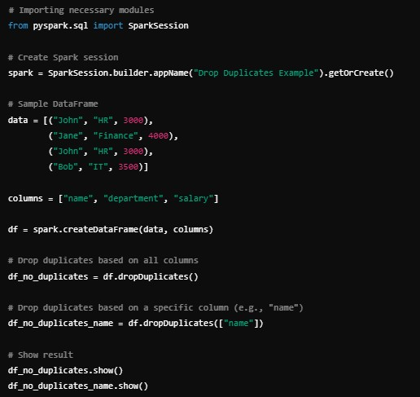

**19. How to Give Permission to a Notebook to Other Users – Steps in Databricks**

To give permission to a notebook to other users in Databricks, you need to set the appropriate permissions for the notebook. Here's how you can do it:

**Steps:**

1. **Navigate to the Notebook**:

Go to the Workspace section in Databricks.

Locate the notebook for which you want to grant access.

2. **Open Permissions Settings**:

Right-click on the notebook and select Permissions from the context menu. Alternatively, you can open the notebook, and then click on the "Share" button at the top right corner.

3. **Add Users or Groups**:

In the permissions panel, you will see the option to add Users or Groups. Type the name of the user or group you want to give access to.

4. **Set Permissions**:

You can assign different levels of access:

**Can Edit**: Allows the user to modify the notebook.

**Can View**: Allows the user to only view the notebook but not make any changes.

**Can Run**: Allows the user to run the notebook.

5. **Save Permissions**:

After selecting the appropriate permissions, click Save to apply the changes.

This ensures that the user or group will have the required permissions to access and work with the notebook.